PS LAB5

Gammanpila J.P.

**Exercise**



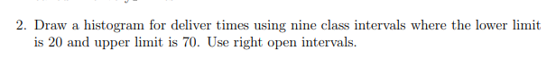



* The shape is roughly bell-shaped (unimodal) with most of the delivery times clustered around 40 minutes.





